Use-Case Realization Report (Requirements)
Transfer All Cash

Issue 3.0
Revision History
Date | Issue | Description | Author
17 July 2000 | 1.0 | First Issue | Howard Russon
19 July 2001 | 2.0 | Revised for MTech Unit 3 in 2001 | Howard Russon
22 July 2004 | 3.0 | Revised for MTech Unit 3 in 2004 | Howard Russon

Table of Contents
1. Brief Description 4
2. Flow of Events 4
2.1 Standard Flow 4
2.2 Exceptions 4
3. Interaction Diagrams 4
3.1 Domain Collaboration Diagram: Transfer All Cash 4
4. Participating Objects 5
5. Class Diagrams 6
5.1 Domain Class Diagram: Transfer All Cash 6
6. Derived Requirements 6

Use-Case Realization Report
Transfer All Cash

Brief Description
This abstract use case enables all the coins in the vending machine to be issued to the Maintainer.

Flow of Events
The standard flow of events for this use case and any exceptions are described in the following subsections. See section 3.1 for an overview of the participating Actors and Domain Objects.

Standard Flow
This use case is used by use case System Maintenance to enable the Maintainer to collect all the cash currently held by the vending machine as follows:
- The total amount of cash held within the machine will be issued to the user (ie: the Maintainer) by pressing the button with the caption “Press to Collect All Cash”.
- The total cash will then be displayed next to the caption “Collect Cash”.
- The internal records of the machine will then be reset to zero ie: the machine will zero coins of each denomination.
- The Machinery Simulator Panel will be updated to show zero coins in each denomination.

Exceptions
The following exceptions have been identified:
- Fault is Detected. If, in the process of issuing the cash to the Maintainer, the sensors detect a fault in the internal mechanism of the vending machine, then a fault message should be returned. Note that his faults is not required to be represented by the simulation.

Interaction Diagrams

Domain Collaboration Diagram: Transfer All Cash
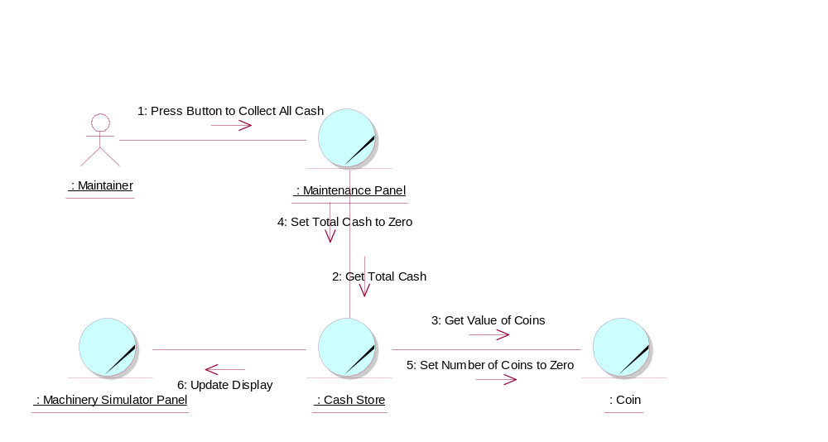

Participating Objects
: Cash Store
This is the repository for all Coins entered into the system. It is also where all change given to the Customer is taken from.
: Coin
The object stores the characteristics of coins entered into the system.
: Machinery Simulator Panel
This panel simulates the physical actions of the maintainer. It enables the user to:
1 display and enter new values for the number of cans of each Drinks Brand held by the Drinks Store;
2 display and enter new values for the number of Coins of each denomination held by the Cash Store;
3 display whether the vending machine Door is unlocked, and enable it to be locked.
: Maintainer
This actor represents the vending machine maintainer who will have a simple display panel to enable stock levels of drinks-cans and change to be monitored, and to enable cash within the machine to be collected.
: Maintenance Panel
This panel simulates the vending machines maintainer control panel. It will enable the user (the Maintainer) to:
1 log-on using a password;
2 display number of Coins of each denomination in the Cash Store;
3 display total value of cash in the system;
4 display number cans of each Drinks Brand held in the Drinks Store;
5 change the price of any Drinks Brand;
6 collect all cash held in system;
7 formally exit from the panel.

Class Diagrams

Domain Class Diagram: Transfer All Cash
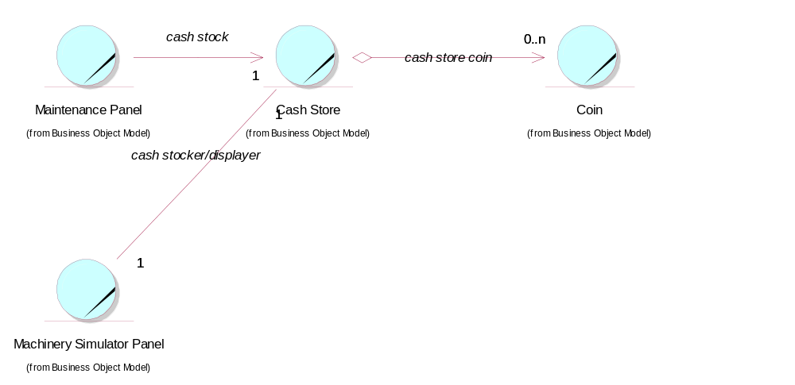

Derived Requirements
In the target implementation, a physical cash tray is required to be built into the Maintenance Panel to catch the cash, so it can be collected by the Maintainer.

